Company Name:
Contact Person: |  | Phone:
E-mail address:
Billing Address:
Billing Address:
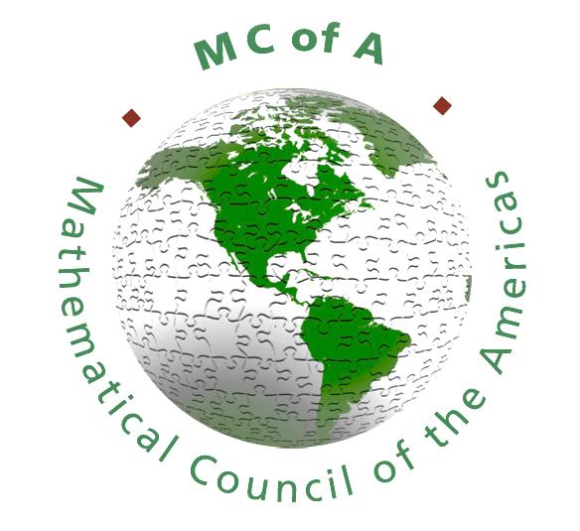  City |  | Postal Code:
Representatives: | 1. | 2.
 | 3. | 4.

 | Exhibit |  |  | $600 ($500 CMS Member)
 | Mathematical Societies |  |  | Complimentary
 | Additional Representatives |  |  | $60 each
 | Books, Journals, Catalogues, Flyers, Posters |  |  | $30 each
 | Registration package insert |  |  | $150 each
 | Full page conference program advertising |  |  | $150
 | Half page conference program advertising |  |  | $90
 | Sponsorship Opportunities |  |  | $__________
 |  |  |  | Subtotal
 |  |  |  | 5% GST
 | Banquet tickets (HST not applicable) |  |  | $70 each
(GST # 11883 3979 RT0001) |  |  |  | TOTAL

 | Cheque |  |  | VISA |  |  | Mastercard

If you wish to pay by credit card, please email this form and then phone us at (613) 733-2662 ext 733

The undersigned agrees to abide by all requirements mentioned in the RULES FOR EXHIBITING.
Please send completed forms to meetings@cms.math.ca or by mail to Attn: Sarah Watson, 209-1725 St. Laurent Blvd, Ottawa ON, K1G 3V4

